APPENDIX A
PHOTOGRAPHS TAKEN DURING JIV AT 6” NEMBE-SOUTH/OBAMA FLOWLINE, AT SABATORU (OBIAMA), NEMBE LGA, BAYELSA STATE ON 20TH DECEMBER, 2024.
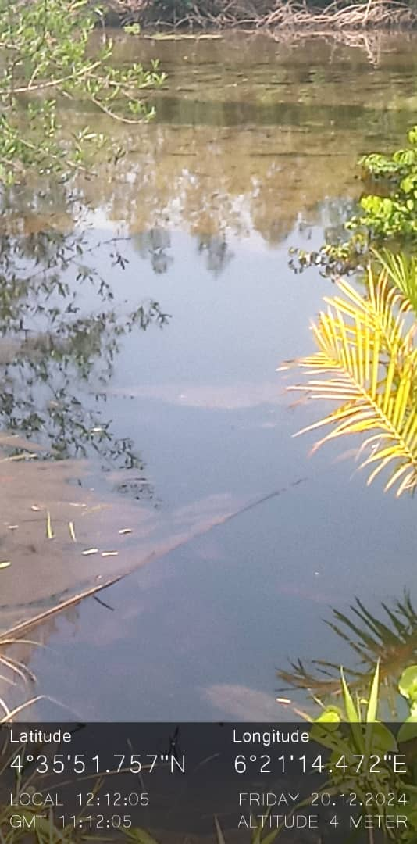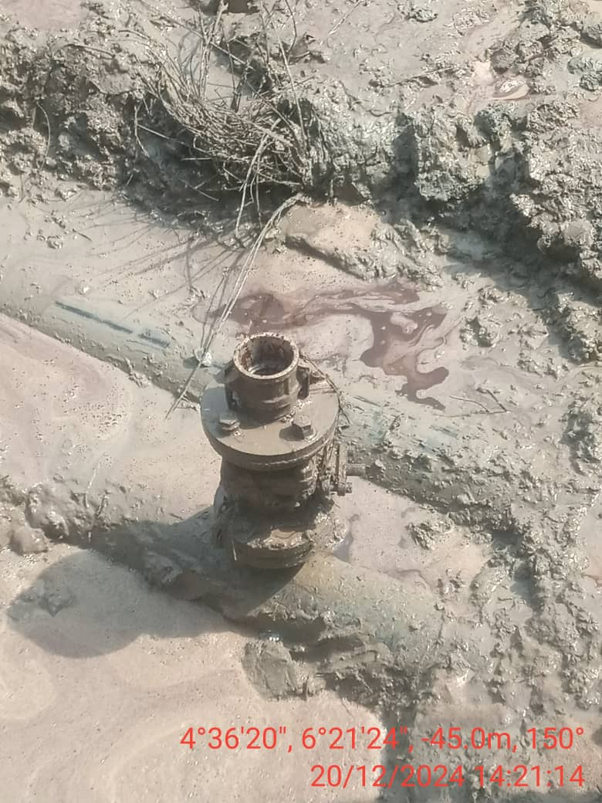
FIG. 1: STATE OF THE ENVIRONMENT ON 20/12/ 2024. FIG. 2: THE INSTALLED 2” VALVE THAT WAS OPENED BY UNKNOWN PERSON(S)
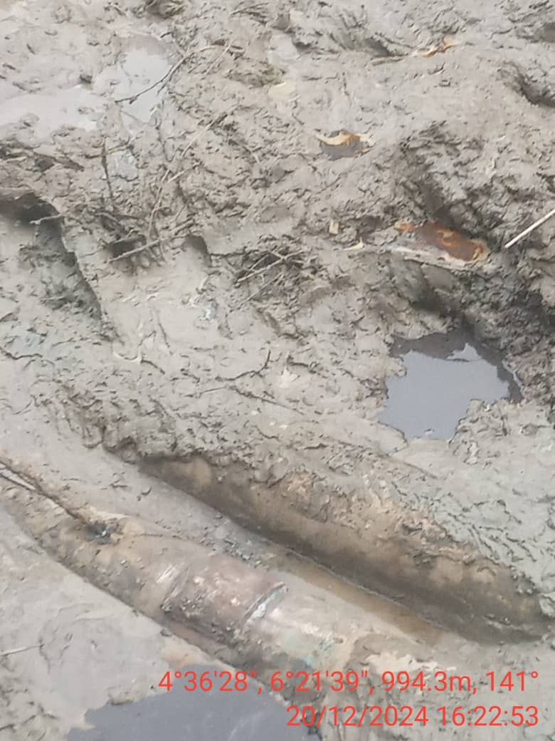
FIG. 3: THE INCIDENT POINT AFTER REPAIRS.

